DTL (Django Template Language)
Django provides special language for generating dynamic content.
Django template language provides special tags which are used for generating dynamic content or inserting data within template(html) dynamically.

- {{variable-name}} 🡪 inserting values
- {%if%}..{%else%} 🡪 conditional tag
- {%for%}…{%endfor%} 🡪 for loop
- {%load static%} 🡪 loading static resources
- {%extends%} 🡪 template inheritance
- {%block%}…{%endblock%} 🡪 overriding content of base class template within derived class
- {%csrf_token%} 🡪 This tag is used for generating cross site request forgery token, when sending request using POST method

{%include%}
This tag is used for including one template inside another template
This allows only reusability but does not allows extensibility

In the Django Template Language (DTL), the {% include %} tag is a powerful tool for modularizing your code. It lets you load a template and render it within the current page, which is perfect for reusable components like navigation bars, footers, or contact forms.

Syntax: {%include “template-name”%}

Views.py

from django.shortcuts import render

# Create your views here.

def view1(request):
response=render(request,"temp1.html")
return response

def view2(request):
response=render(request,"temp2.html")
return response

temp1.html
<!DOCTYPE html>
<html lang="en">
<head>
<meta charset="UTF-8">
<meta name="viewport" content="width=device-width, initial-scale=1.0">
<title>Template1</title>
</head>
<body>
{%include "navbar.html" %}
<h2>This template1</h2>
</body>
</html>

Temp2.html
<!DOCTYPE html>
<html lang="en">
<head>
<meta charset="UTF-8">
<meta name="viewport" content="width=device-width, initial-scale=1.0">
<title>Template2</title>
</head>
<body>
{%include "navbar.html" %}
<h2>This is template2</h2>
</body>
</html>

Navbar.html
<!DOCTYPE html>
<html lang="en">
<head>
<meta charset="UTF-8">
<meta name="viewport" content="width=device-width, initial-scale=1.0">
<link rel="stylesheet" href="https://cdn.jsdelivr.net/npm/bootstrap@4.0.0/dist/css/bootstrap.min.css" integrity="sha384-Gn5384xqQ1aoWXA+058RXPxPg6fy4IWvTNh0E263XmFcJlSAwiGgFAW/dAiS6JXm" crossorigin="anonymous">
</head>
<body>
<nav class="navbar navbar-expand-lg navbar-light bg-light">
<a class="navbar-brand" href="#">Navbar</a>
<button class="navbar-toggler" type="button" data-toggle="collapse" data-target="#navbarNavAltMarkup" aria-controls="navbarNavAltMarkup" aria-expanded="false" aria-label="Toggle navigation">
<span class="navbar-toggler-icon"></span>
</button>
<div class="collapse navbar-collapse" id="navbarNavAltMarkup">
<div class="navbar-nav">
<a class="nav-item nav-link active" href="#">Home <span class="sr-only">(current)</span></a>
<a class="nav-item nav-link" href="#">Features</a>
<a class="nav-item nav-link" href="#">Pricing</a>
<a class="nav-item nav-link disabled" href="#">Disabled</a>
</div>
</div>
</nav>
</body>
</html>

Urls.py
from django.contrib import admin
from django.urls import path
from app.views import view1,view2
urlpatterns = [
path('admin/', admin.site.urls),
path('view1/',view1),
path('view2/',view2),
]

Settings.py

INSTALLED_APPS = [
'django.contrib.admin',
'django.contrib.auth',
'django.contrib.contenttypes',
'django.contrib.sessions',
'django.contrib.messages',
'django.contrib.staticfiles',
'app'
]

TEMPLATES = [
{
'BACKEND': 'django.template.backends.django.DjangoTemplates',
'DIRS': [BASE_DIR/"templates"],

What is difference between {%include%} and {%extends%}
{%include%} | {%extends%}
This allows reusability | This allows reusability and extensibility
This tag can be used any number of times within template | This tag is used only one time
This allows to add content of existing template into current template | This tag is used to add more content to existing template by overriding blocks

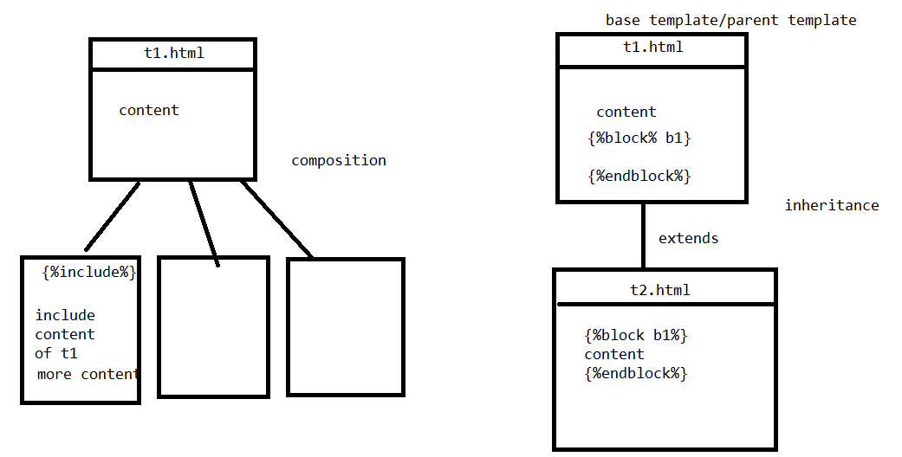

{%url%}

The {% url %} tag in the Django Template Language (DTL) is a built-in tool used to link to specific views without hardcoding absolute paths. This follows the DRY (Don't Repeat Yourself) principle, ensuring that if you change a URL path in your urls.py, all your links update automatically.

Basic Syntax
The general format for the tag is:
{% url 'view-name' arg1 arg2 %}]

'view-name': The name given to the path in your urls.py.
Arguments: Optional positional or keyword arguments required by the URL pattern

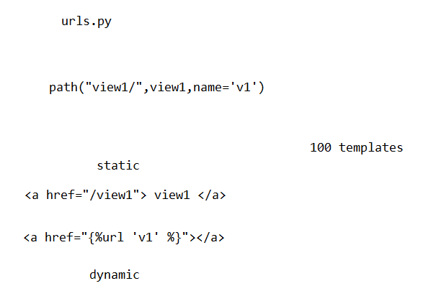

temp3.html
<!DOCTYPE html>
<html lang="en">
<head>
<meta charset="UTF-8">
<meta name="viewport" content="width=device-width, initial-scale=1.0">
<title>Demo of URL Tag</title>
</head>
<body>
<a href="{%url 'v1' %}">View1</a>
<a href="{%url 'v2' %}">View2</a>
<a href="{%url 'v4' 'naresh' 50%}">View4</a>
</body>
</html>

Views.py
def view3(request):
response=render(request,"temp3.html")
return response

def view4(request,name,age):
response=HttpResponse(f'<h2>{name},{age}</h2>')
return response

urls.py
from django.contrib import admin
from django.urls import path
from app.views import view1,view2,view3,view4
urlpatterns = [
path('admin/', admin.site.urls),
path('view1/',view1,name='v1'),
path('view2/',view2,name='v2'),
path('view3/',view3),
path('view4/<str:name>/<int:age>/',view4,name='v4'),
]

djnago filters (OR) django template filters

django template filters are used for formatting data.
These template filters are 2 types
- Predefined template filters
- User defined template filters/Custom template filters

Predefined template filters
These are existing template filters provided django template language.

These are used with the pipe | character to modify variables before they are rendered.

Syntax: {{data |filter-name }}

